**Problem 1.** The following database design is given to you and you are expected to

answer the queries given in (*a*) to ( *j*) using SQL.

*Opening (Account Number, open date, Opening Balance, Total Deposit,*

*Total Withdrawl, Closing Balance, Closing Balance Date, Last deposit Date, Last Withdrawal*

*Date)*

*Deposit (Account Number, Data, Amount, Mode)*

*Withdrawl (Account Number, Date, Amount, Mode)*

*Account Holder (Account Number, Name, Building Number, Area Number, Street Number,*

*City Code, Pin Code, State Code)*

*Cities (City Code, City Name, State Code)*

*State (State Code, State Name)*

(*a*) List of all Account Number having no deposits in Jan, 2000.

(*b*) List of all Account Number having total withdrawal more than ` 10,000 in Jan, 2000.

(*c*) List of all Account Number having neither any depositor any withdrawal in

Jan, 2000.

(*d*) List of Account Number and Name of Account holders from city ROHTAK whose

opening balance is not less than ` 9,999.

(*e*) List of all cities of the state HARYANA.

(*f* ) List of all Account Number and Total Deposits in Feb, 2000 for those Account

Holders who belongs to state HARYANA.

(*g*) List of all city Names from which there is no Account Holders.

(*h*) List of all states from which more than 999 Account Holders are there.

(*i*) List of all Account Number which do not have any transactions after opening.

(*j*) List of all city name and their pin code for cities of state RAJASTHAN.

**Problem 2. Consider the following tables**

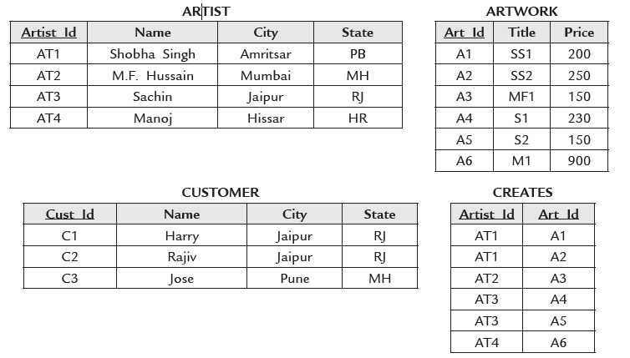

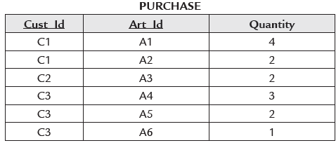

Write the SQL for the following queries:

1. Find the name of the artist who has created the Artwork titled ‘SS2’

2. Find the ids of customers who have bought more than two different artworks.

3. Find the titles of the Artworks created by ‘Sachin’.

4. Find the titles of the artwork bought by customers who live in ‘Jaipur’.

5. Find the names of customers who have not bought an artwork priced more than

$200.

6. Find the names of customers who did not buy artworks created by ‘Manoj’.

7. Find the names of customers who have spent more than $1500.

8. Find the ids of customers who have bought all artworks created by ‘Shobha Singh’.

9. Find the names of the artists whose work is priced 2nd highest.

10. Find the names of customers who have bought artwork created by an artist from

their own city.

**Problem 3:**

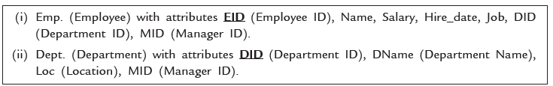

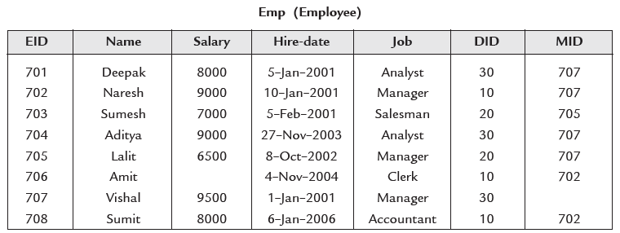

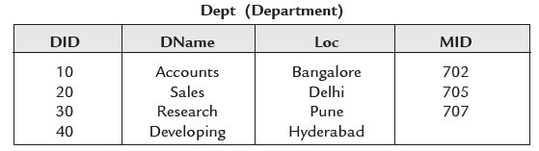

Write SQL Queries for

1. Suppose you want to increase salary of each employee by 500.
2. List the name of employees having salary 9000.
3. List the name of employees having salary not equal to 9000.
4. List name and EID of employees having salary ` 8000 or ` 9500.
5. List the EID and names of employees who were hired by company from

5–Feb–2001 to 1–Jan–2006.

6. List the EID and names of employees having MID equal to null.

7. List the names of employees ending with ‘it’.

8. List the names of employees having second alphabet of their names is ‘*a*’ .

9. List name of employees having salary less than ` 8500 and MID is 707.

10. List name of employees having salary greater than ` 9200 or first alphabet of his name

is ‘D’.

**Problem 4:**







Write SQL Queries for

11. List name of employees having MID is not equal to 707.

12. List name of employees in ascending order.

13. List name of employees in descending order according to their hire date

and having salary greater than ` 7500.

14. Display the EID, number of months employed of employees having salary

more than ` 8500. Suppose system date is 01-Jan-06.

15. Display the Current Date

16. Display the name of the month in Char by taking date in dd-month-yy

17. Display the number of the month by taking the date in char.

18. Display EID and DName of all employees by joining over DID.

19. Display EID and DName of employees having MID 705 or 707

20. Display EID and DName of employees by joining over MID

**Problem 5:**







Write SQL Queries for:

21. Display the name of employees and name of their managers.

22. Display EID and DName of employees by joining over MID. (By using

left outer join, Right outer join and Full outer join).

23. Display job and average salary paid by company for a particular job.

24. Display job and average salary paid by company for a particular job in

descending order according to their average salary and average salary must

be greater than 7500.

25. Display Name of those employees having same DID as that of Sumit.

It is required to find out DID of Sumit to solve this query. (Single Row

Subquery).

26. List name and salary of only those employees having salary more than

any of the employee working as Analyst.

27. List name and salary of only those employees having salary more than

every employee working as Analyst.

28. List the EID and names of employees having MID equal to null.

29. List the names of employees ending with ‘it’.

30. List the names of employees having second alphabet of their names is ‘a’ .

**Problem 6:**

**Consider the following relational DATABASE. Give an expression in SQL for each following queries. Underline records are primary key**

**Employee(person**_**name, street, city)**

**Works(person**_**name, Company_name, salary)**

**Company(Company**_**name, city)**

**Manages(person**_**name, manager_name)**

1. Finds the names of all employees who works for the ABC bank.
2. Finds the name of all employees who live in the same city

and on the same street as do their managers.

1. Find the name street address and cities of residence of all employees who work for ABC bank and earn more than 7,000 per annum.
2. Find the names of all employee who earn more than every employee of XYZ.
3. Give all employees of corporation ABC a 7% salary raise.
4. Delete all tuples in the works relation for employees of ABC.
5. Find the name of all employees in this DATABASE who live in the same city as the company for which they work.
6. Deduct 10% of the salary as tax for Employees in ABC
7. Display the names of all the employees who lives in Chennai
8. Display the manager name of the employee who belongs to Mumbai.

**Problem 7:**

**Consider the following relations :**

**Student (ssn, name, address, major)**

**Course (code, title)**

**Registered (ssn, code)**

**Use SQL to answer the following:**

a. List the codes of courses in which at least one student is registered (registered courses).

b. List the title of registered courses.

c. List the codes of courses for which no student is registered.

d. The titles of courses for which no student is registered.

e. Name of students and the titles of courses they registered to.

f. SSNs of students who are registered for both Database Systems and Analysis of Algorithms.

g. SSNs of students who are registered for both Database Systems and Analysis of Algorithms.

h. The name of students who are registered for both Database Systems and Analysis of Algorithms.

i. List of courses in which all students are registered.

j. List of courses in which all ‘ECMP’ major students are registered.